January 24th, 2010
Hi
As I mentioned last week, the legislative council finally approved the funds for the so-called high-speed railway last Saturday evening. But after that, the protesters outside the building would not let the government officials responsible for the railway out of the council building. There was quite a fight with the police who resorted to using pepper spray. (Many protestors had anticipated this and hung plastic sheets over their faces.) A couple of days later, instead of initiating any sort of dialogue with the protesters, the government got verbally tough over the way the students behaved and threatened them with the full force of the law. People in HK are pretty certain from where the instructions came from to take the tough line. This is even worse than in colonial days when the then government had very good links with the public and advisory bodies and would also talk with dissidents and protesters.


Went to the supermarket the other day with $300 in coupons from the Hang Seng Bank, who issued my credit card. For every $250 I spend with the credit card, I earn $1, which can be redeemed in many ways, though I always choose Park ‘n Shop vouchers. Also, while in the queue, a lady in a group from Guangdong (I assumed she was from there as the group she was with spoke both Mandarin and Cantonese) handed me an addition al coupon worth $30 coupon. That sort of thing does not happen very often, I think the last time was in 1994 when we were queuing up to buy tickets for Legoland. A lady from Holland had an entry ticket that she could not use and gave it to us. Do any of you remember that? Do you even remember visiting Legoland?
The run yesterday was from CU up Ma On Shan and back. Took 3 hr 13 min, my slowest even though it felt all right. However, because it was damp and misty, most of the rocks on the trails were very slippery, so I was very cautious, not wanting to repeat the terrible fall I had coming back on this route a few years ago.

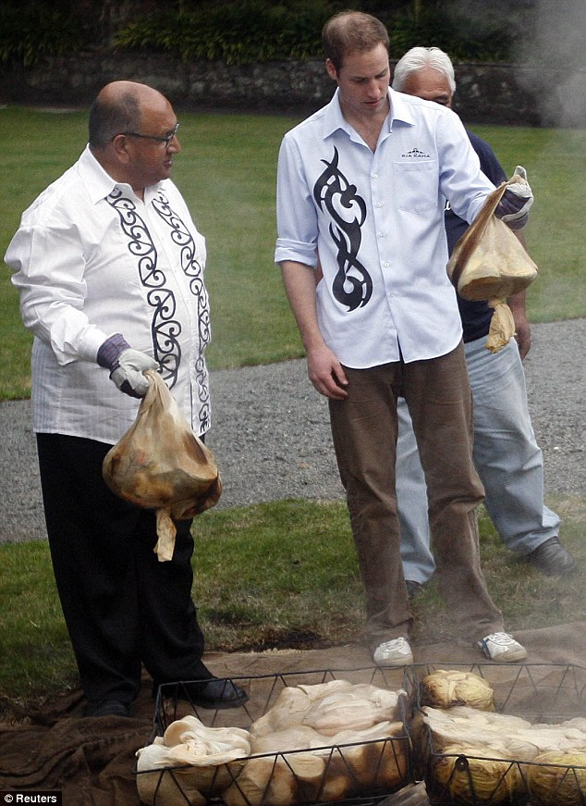
Prince William has been in NZ and Australia this past week. He is making his first official visit in place of the Queen. Very informal, quite unlike what would happen for a visit by the Queen. (Pics show him at a greeting before opening a new Supreme Court building in Wellington and at a Maori hangi.
Also saw on Australian TV news an interesting item also from NZ. In the north on the North Island is an island with a large hole called the ‘Hole in the Rock’ (pic below). A parachutist from Hungary attempted to paraglide through the hole. He almost made it, but ended up in the water just short. To get through, he had to approach at about 200 km/h; imagine if he had hit the rock at that speed. Check out the videos:
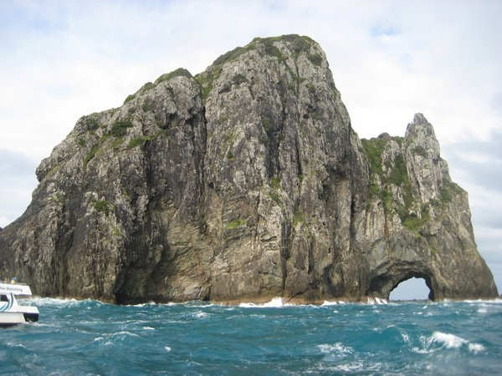
http://www.necn.com/Boston/World/2010/01/19/Skydiver-attempts-to-jump/1263899994.html
Or, a more detailed video from tvnz:
http://tvnz.co.nz/national-news/sky-diving-through-hole-in-rock-3334882/video
Still too few people getting swine flu jabs. The doctor who got G-B syndrome has recovered. The number of deaths from swine flu is up to about 70.
That’s about it for now. Not that much this week.

Cheers

